**VEHICLE INSURANCE DATBASE**

Create a table with name POLICY having the following attributes:

CREATE table POLICY

(

Customer_id Varchar(15) not NULL,

Name Varchar(30) not NULL,

Type_of_vehivle Varchar(10) not NULL,

Vehicle_class varchar(5),

Reg_no varchar(10)

Policy_no int Primary key,

Premium int,

Start_date varchar(10),

);

1. Add End _date attribute to the table of type DATE.
2. Insert the following details into the table.

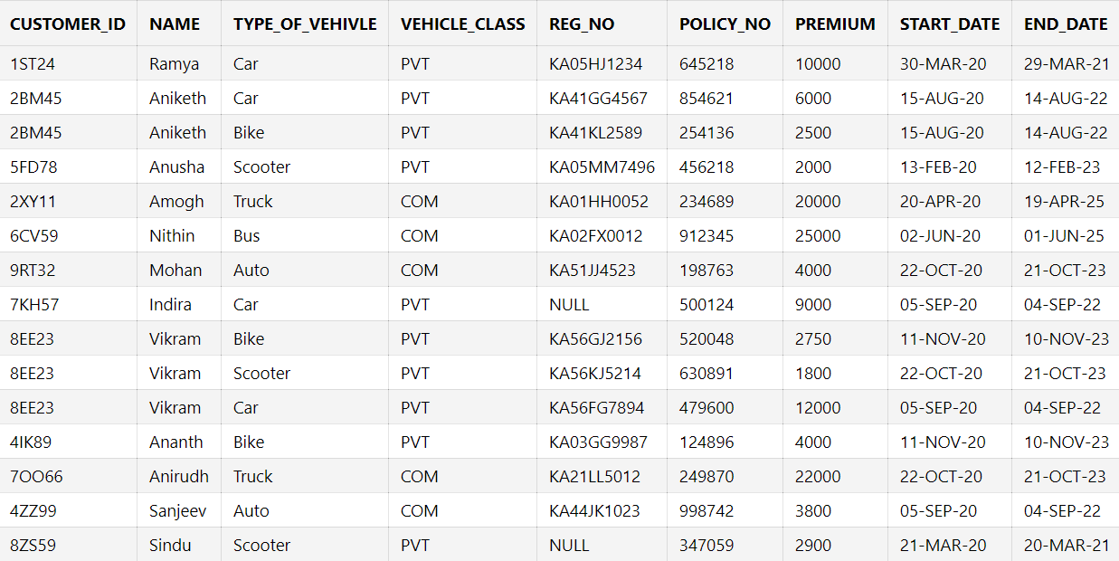

1. Display all the records of the POLICY table.
2. Display customer_id, name and policy_no of all the records in the table.
3. Display details of all who has taken a CAR insurance .
4. Display the count of COMMERTIAL vehicles.
5. Display all records with PREMIUM greater than or equal to 10,000.
6. Display all the records with NAME as Vikram and calculate the SUM of his premiums.
7. Display all the records with End_date between 01-JAN-2021 to 31-DEC-2021.
8. Display all the records with Start_date 05-SEP-2020 and End_date 04-SEP-2022.
9. Count and Display all the records of all the vehicles which are not COMMERTIAL.
10. Display all the records for BIKE and SCOOTER insurance.
11. Display distinct customer_id and name .
12. Display the type_of_vehicle,reg_no of all the vehicles with customer_id = 2BM45.
13. Display all the vehicles without reg_no.
14. Update the reg_no of SINDHU with KA55LK2956 and display .
15. Sort all the records according to PREMIUM.
16. Display the PREMIUM for the vehicle with policy_no 249870.
17. There was a name transfer for the vehicle with reg_no KA41KL2589

Change the below details only and display:

* Name: Rama
* Customer_id: 2PO59

1. Delete entry with customer_id 2BM45 and policy_no 854621.

**SOLUTIONS**

1. Add End _date attribute to the table of type DATE.

**ALTER table POLICY add End_date DATE;**

2. Insert the following details into the table.

**INSERT into POLICY values('1ST24','Ramya','Car','PVT','KA05HJ1234',645218,10000,'30-MAR-2020','29-MAR-2021');**

**INSERT into POLICY values('2BM45','Aniketh','Car','PVT','KA41GG4567',854621,6000,'15-AUG-2020','14-AUG-2022');**

**INSERT into POLICY values('2BM45','Aniketh','Bike','PVT','KA41KL2589',254136,2500,'15-AUG-2020','14-AUG-2022');**

**INSERT into POLICY values('5FD78','Anusha','Scooter','PVT','KA05MM7496',456218,2000,'13-FEB-2020','12-FEB-2023');**

**INSERT into POLICY values('2XY11','Amogh','Truck','COM','KA01HH0052',234689,20000,'20-APR-2020','19-APR-2025');**

**INSERT into POLICY values('6CV59','Nithin','Bus','COM','KA02FX0012',912345,25000,'02-JUN-2020','01-JUN-2025');**

**INSERT into POLICY values('9RT32','Mohan','Auto','COM','KA51JJ4523',198763,4000,'22-OCT-2020','21-OCT-2023');**

**INSERT into POLICY values('7KH57','Indira','Car','PVT','NULL',500124,9000,'05-SEP-2020','04-SEP-2022');**

**INSERT into POLICY values('8EE23','Vikram','Bike','PVT','KA56GJ2156',520048,2750,'11-NOV-2020','10-NOV-2023');**

**INSERT into POLICY values('8EE23','Vikram','Scooter','PVT','KA56KJ5214',630891,1800,'22-OCT-2020','21-OCT-2023');**

**INSERT into POLICY values('8EE23','Vikram','Car','PVT','KA56FG7894',479600,12000,'05-SEP-2020','04-SEP-2022');**

**INSERT into POLICY values('4IK89','Ananth','Bike','PVT','KA03GG9987',124896,4000,'11-NOV-2020','10-NOV-2023');**

**INSERT into POLICY values('7OO66','Anirudh','Truck','COM','KA21LL5012',249870,22000,'22-OCT-2020','21-OCT-2023');**

**INSERT into POLICY values('4ZZ99','Sanjeev','Auto','COM','KA44JK1023',998742,3800,'05-SEP-2020','04-SEP-2022');**

**INSERT into POLICY values('8ZS59','Sindu','Scooter','PVT','NULL',347059,2900,'21-MAR-2020','20-MAR-2021');**

3. Display all the records of the POLICY table.

**SELECT * from POLICY;**



4. Display customer_id, name and policy_no of all the records in the table.

**SELECT Customer_id,Name,Policy_no from POLICY;**

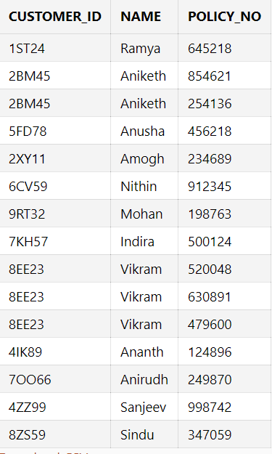

5. Display details of all who has taken a CAR insurance .

**SELECT * from POLICY where Type_of_vehicle='Car';**

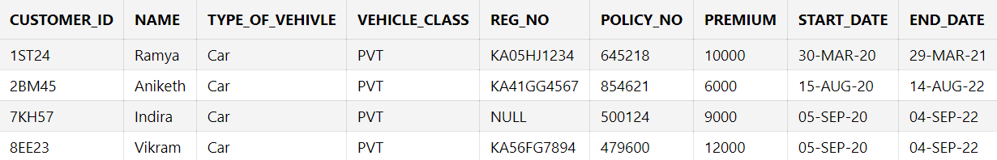

6. Display the count of COMMERTIAL vehicles

**SELECT COUNT(Vehicle_class) from POLICY where Vehicle_class='COM';**

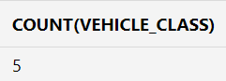

7. Display all records with PREMIUM greater than or equal to 10,000.

**SELECT * from POLICY where PREMIUM>=10000;**

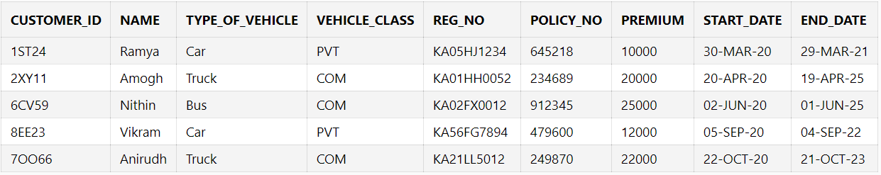

8. Display all the records with NAME as Vikram and calculate the SUM of his premiums.

**SELECT * from POLICY where name='Vikram';**

**SELECT SUM(premium) from POLICY where name='Vikram';**

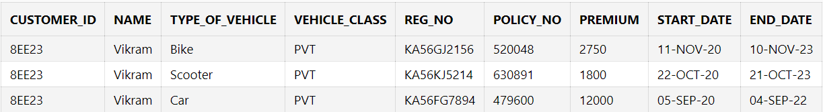

9. Display all the records with End_date between 01-JAN-2021 to 31-DEC-2021.

**SELECT * from POLICY where End_date >='01-JAN-2021' and End_date<='31-DEC-2021';**

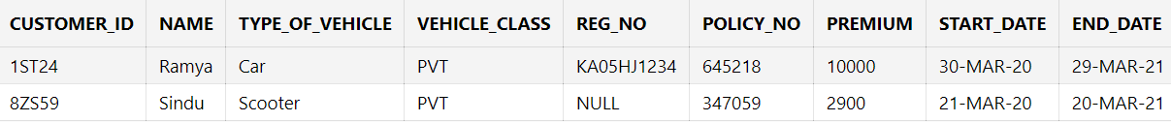

10. Display all the records with Start_date 05-SEP-2020 and End_date 04-SEP-2022.

**SELECT * from POLICY where Start_date=' 05-SEP-2020' and End_date=' 04-SEP-2022';**

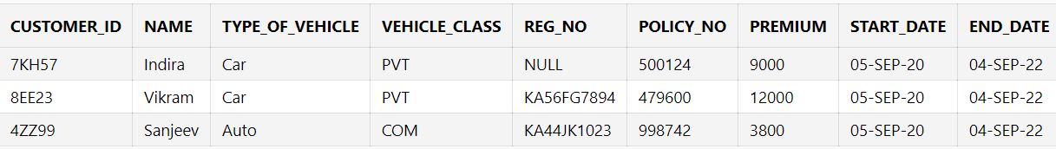

11. Count and Display all the records of all the vehicles which are not COMMERTIAL.

**SELECT COUNT(Vehicle_class) from POLICY where Vehicle_class!='COM';**

**SELECT * from POLICY where Vehicle_class!='COM';**

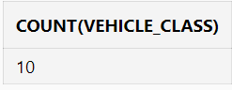

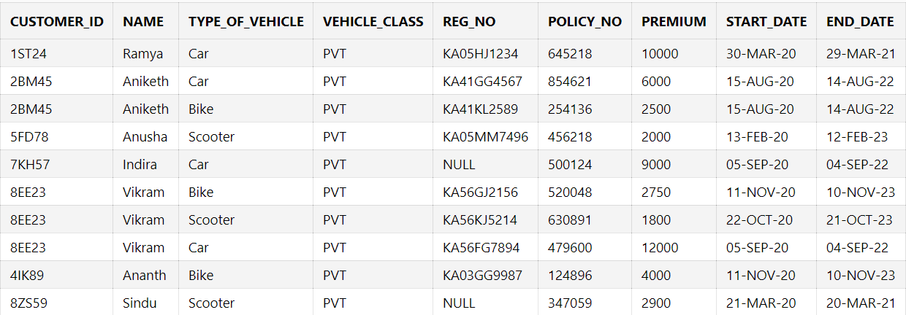

12.Display all the records for BIKE and SCOOTER insurance.

**SELECT * from POLICY where Type_of_vehicle='Bike' or Type_of_vehicle='Scooter';**

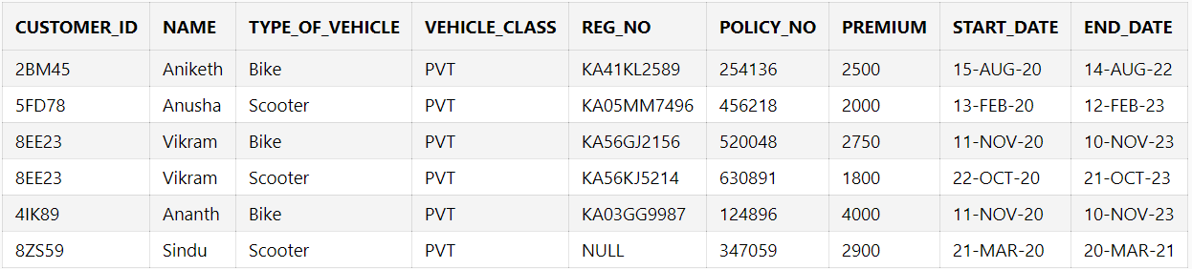

13. Display distinct customer_id and name .

**SELECT DISTINCT customer_id,name from POLICY;**

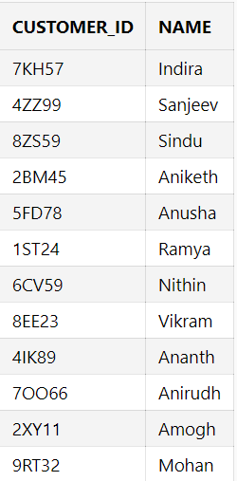

14. Display the type_of_vehicle,reg_no of all the vehicles with customer_id = 2BM45.

**SELECT type_of_vehicle,reg_no from POLICY where Customer_id='2BM45';**

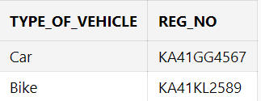

15. Display all the vehicles without reg_no.

**SELECT * from POLICY where reg_no='NULL';**

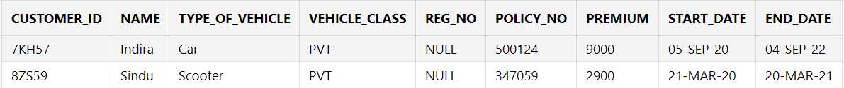

16. Update the reg_no of SINDHU with KA55LK2956 and display .

**UPDATE POLICY SET Reg_no='KA55LK2956' where NAME='Sindu';**

**SELECT * from POLICY where Reg_no='KA55LK2956';**



17. Sort all the records according to PREMIUM.

**SELECT * from POLICY ORDER BY premium ASC;**

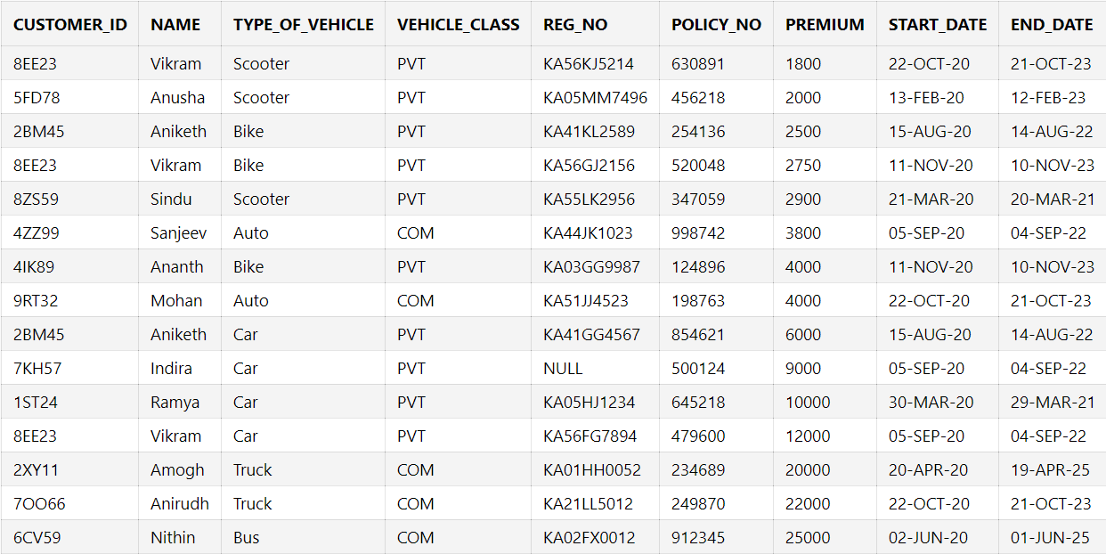

18. Display the PREMIUM for the vehicle with policy_no 249870.

**SELECT premium from POLICY where policy_no = 249870;**

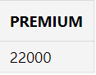

19. There was a name transfer for the vehicle with reg_no KA41KL2589

Change the below details only and display:

* Name: Rama
* Customer_id: 2PO59

**UPDATE POLICY set Customer_id='2PO59',Name='Rama' where reg_no='KA41KL2589';**

**SELECT * from POLICY where reg_no='KA41KL2589';**



20. Delete entry with customer_id 2BM45 and policy_no 854621.

**DELETE from POLICY where customer_id= '2BM45' and policy_no='854621';**

**Select * from POLICY;**

